**Bilkent University**

**Computer Engineering**

**Computer Organization – CS224**

**Design Report**

**Lab # 4**

**Section # 4**

**Mannan Abdul**

**21801066**

**14/04/2020**

**Part B**

|  |  |  |
| --- | --- | --- |
| Location (In Hex) | Machine Instruction (In Hex) | Assembly Code |
| 0x00 | 0x20020005 | addi $v0, $zero, 5 |
| 0x04 | 0x2003000c | addi $v1, $zero, 12 |
| 0x08 | 0x2067fff7 | addi $a3, $v1, -9 |
| 0x0c | 0x00e22025 | or $a0, $a3, $v0 |
| 0x10 | 0x00642824 | and $a1, $v1, $a0 |
| 0x14 | 0x00a42820 | add $a1, $a1, $a0 |
| 0x18 | 0x10a7000a | beq $a1, $a3, 10 |
| 0x1c | 0x0064202a | slt $a0, $v1, $a0 |
| 0x20 | 0x10800001 | beq $a0, $zero, 1 |
| 0x24 | 0x20050000 | addi $a1, $zero, 0 |
| 0x28 | 0x00e2202a | slt $a0, $a3, $v0 |
| 0x2c | 0x00853820 | add $a3, $a0, $a1 |
| 0x30 | 0x00e23822 | sub $a3, $a3, $a1 |
| 0x34 | 0xac670044 | sw $a3, 68($v1) |
| 0x38 | 0x8c020050 | lw $v0, 80($zero) |
| 0x3c | 0x08000011 | j 0x0000011 |
| 0x40 | 0x20020001 | addi $v0, $zero, 1 |
| 0x44 | 0xac020054 | sw $v0, 84($zero) |
| 0x48 | 0x08000012 | j 0x0000012 |

**Part C**

RTL expression for “jm”:

IM[PC];

PC ← RF[rs] + SignExt(immed);

RTL expression for “bgt”:

IM[PC];

If(RF[rs] > RF[rt])

PC ← PC + 4 + SignExt(immed) * 4;

else

PC ← PC + 4;

**Part D**

**Jm (red lines in datapath):**

We add a new signal named “jm” from the control unit for this instruction. The instruction needs only one new piece of hardware to load the result into the PC. This multiplexer is shown in red in the figure along with its control signal. The PC’ needs to be loaded with the sum of the address in the register and the sign extended offset which we get in the result, the necessary control signals will be shown in the table in the next part.

**Bgt (green lines in datapath):**

A bgt instruction can be broken down into 2 steps, first we use the slt instruction to check 2 values, then we check the result in the ALU and act on it. As such, for this instruction, we have added 2 multiplexers that will exchange the places of rs and rt when bgt is 1. We will set the ALU to set less than and it will check if rt is less then rs, if it is it will output 1 and we will take that result and apply and AND gate to it and the bgt signal to check if the result 1 is consistent with the signal, we also put an OR gate so that we can use the already existing hardware for this purpose to get the next instruction into PC’. Also, because bgt is a I-type instruction, it has no function code, so we add a multiplexer there that manually gives the function code for slt to the control unit.

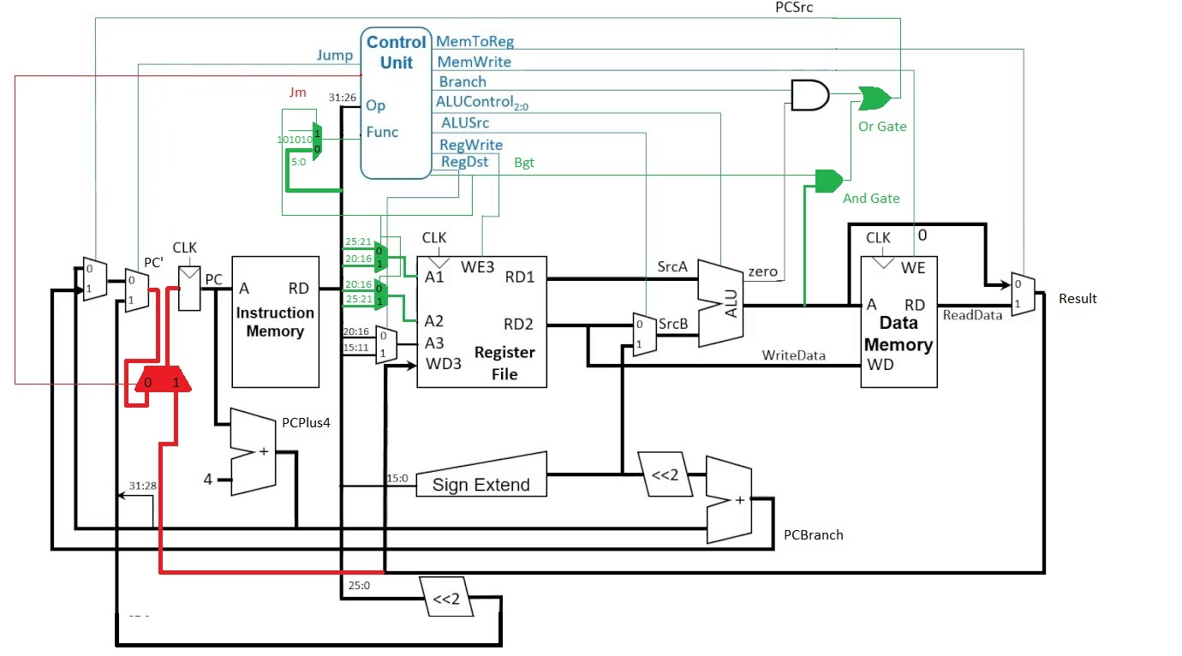

**Part E**

|  |  |  |  |  |  |  |  |  |  |  |  |
| --- | --- | --- | --- | --- | --- | --- | --- | --- | --- | --- | --- |
| Instruction | Opcode | RegWrite | RegDst | ALUSrc | Branch | MemWrite | MemtoReg | ALUOp | Jump | Jm | Bgt |
| R-type | 000000 | 1 | 1 | 0 | 0 | 0 | 0 | 10 | 0 | 0 | 0 |
| lw | 100011 | 1 | 0 | 1 | 0 | 0 | 1 | 00 | 0 | 0 | 0 |
| sw | 101011 | 0 | X | 1 | 0 | 1 | X | 00 | 0 | 0 | 0 |
| beq | 000100 | 0 | X | 0 | 1 | 0 | X | 01 | 0 | 0 | 0 |
| addi | 001000 | 1 | 0 | 1 | 0 | 0 | 0 | 00 | 0 | 0 | 0 |
| j | 000010 | 0 | X | X | X | 0 | X | XX | 1 | 0 | 0 |
| jm | 000001 | 0 | X | 1 | 0 | 0 | 0 | 00 | 0 | 1 | 0 |
| bgt | 000011 | 0 | X | 0 | 0 | 0 | 0 | 10 | 0 | 0 | 1 |

*for bgt, ALUOp is 1X, Funct is 101010 (slt) and ALUControl is 111

**Part F**

To test our new instructions in conjunction with the old ones, we will write a test program that will have R-type, lw, sw, beq, addi, j instructions.

If even one R-type instruction works, we know that the rest will also work because their datapath is the same.

addi $t7, $zero, 4 // checks an addi instruction

addi $t0, $zero, 4

addi $t1, $zero, 10

add $t2, $t0, $t1 // checks an R-type instruction

lw $t3, 0($t2) // checks lw instruction

sw $t3, 0($t6) // checks sw instruction

beq $t7, $t0, 1 // checks beq instruction

sub $t7, $t7, $t0

j 0x00000028 // checks j instruction

sub $t7, $t7, $t0

bgt $t1, $t0, 1 // checks bgt instruction

sub $t7, $t7, $t0

jm 0($t0) // checks jm instruction

This test code will only do the addition on an infinite loop because all the other testers are linked in such a way that they point directly to the next jump/branch instruction and so on. The last instruction points to the first one and therefore will enable an infinite loop.